BALLYMAHON MUNICIPAL DISTRICT

Corporate Affairs,
Aras an Chontae,
LONGFOIRT.

16th March 2017.

To: Each Member of Ballymahon Municipal District.

Dear Member,

You are requested to attend Meeting of Ballymahon Municipal District to be held in Ballymahon Community Library on Thursday, 23rd March 2017 at 4.00 p.m. to transact business, as set out on the Agenda hereunder.

Yours sincerely,
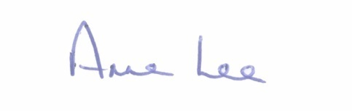

_______________
Anne Lee,
Meetings Administrator.

AGENDA

Prayer before meeting.

1. Confirmation of Minutes of Ballymahon Municipal District Meetings held on the 26th January and 23rd February 2017 - copies enclosed.

2. Matters arising from Minutes.

3. Management Report – to follow.

4. Area Engineer’s Progress Report.

5. Consideration of applications for funding under the 2017 Community Grant Support Scheme - report enclosed.

6. To note Community Facilities Scheme 2017 –summary and documentation attached.

7. Consideration of nominee for 2017 Cathaoirleach’s Awards

8. Nomination of one member of Ballymahon Municipal District to the County Longford Tourism Committee.

9. Consideration of Report in accordance with Section 179 of the Planning and Development Act 2000 (as amended) and Part 8 of the Planning &
Development Regulations 2001 (as amended) in respect of the construction of an Amenity Walkway through the Cutaway Bog surrounding Corlea Trackway at Corlea, Mosstown, Keenagh, Co. Longford - report enclosed.

10. Notices of Motions submitted by Councillors, as listed hereunder -

Councillor Colm Murray.

“I call on Longford County Council to erect solar powered speed warning
signs on the approach roads to Kenagh on the R397.”

Councillor Paul Ross .

"That the footpaths be repaired, where in a poor state, in St. Matthew's Park, Ballymahon."

"That a new car park be put in place for tourists and walkers on the Newcastle Road on the Toome side of Newcastle Forest."

"That the Ballymahon Municipal area be allocated an additional roads crew to comprise of staff and a truck to cope with the extra workload in the area."

11. Correspondence.

- Letter dated 22nd February 2017 received from Lanesborough Tourism
Co-Operative Society Ltd. regarding licence for carnival business.

- Letter dated 13th March 2017 received from Ballymahon-Lendevant Twinning Committee requesting financial support in 2017.

12. A.O.B.

